CONTACT:

Company inquiries: Media inquiries:
Ralph N. Cram Ralph Cram
Envoy Net Lease Partners Envoy Net Lease Partners, LLC (847) 239-7250 info@envoynnn.com

For Immediate Release

ENVOY ANNOUNCES THE EXPANSION OF BUSINESS DEVELOPMENT TEAM

Envoy hires Mr. Bruce W. Neel – Director of Business Development

CHICAGO, February 4th, 2021 — Envoy Net Lease Partners, LLC, a real estate finance company specializing in single-tenant, net lease commercial properties, is proud to announce and welcome Mr. Bruce W. Neel (click for bio) as Director of Business Development to its management team, effective immediately.

Holding a key leadership position, Mr. Neel will assist Envoy with growing its lending business both on a national and regional basis, with the primary focus in the Southeast. Prior to joining Envoy, Bruce has had 27 years of commercial real estate experience and was most recently the EVP and Southeast Regional Director with Plum Lending, a national commercial real estate lender headquartered in San Francisco, CA. He is based in Columbia, South Carolina and may be contacted bneel@envoynnn.com.

“We are thrilled to have Bruce on board.” Says Ralph Cram, Envoy’s President. “Bruce will strengthen our origination and customer service platform in one of the fastest growing regions in the U.S. His past relationships and market knowledge will help us increase our high- leverage, triple-net construction lending volume and joint venture investments in the Southeast and other markets nationwide.”

About Envoy Net Lease Partners, LLC

Based in greater Chicago, Envoy Net Lease Partners is a nationwide provider of build-to-suit financing to developers of single-tenant, net lease properties. Envoy provides capital in the form of high-leverage construction loans, mezzanine debt and equity financing nationwide. Since its inception in 2011, Envoy’s team of investment professionals have closed 81 transactions in excess of $230 million of total project costs for real estate developers and investors, in many cases up to 100% of the capital required to develop the properties. Property types included commercial, industrial, office and medical properties. To learn more please visit envoynnn.com.

Envoy Expands Management Team February 4, 2021
Page 2 of 2

PHOTO & CONTACT INFO ATTACHED

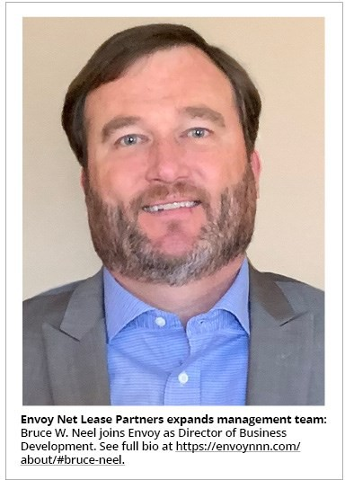

DIRECT CONTACT INFORMATION FOR NEW ENVOY TEAM MEMBER:
Bruce W. Neel
Director of Business Development Envoy Net Lease Partners
Office: (847) 239-6959
Email: bneel@envoynnn.com

